4/22/24, 9:55 AM Mininet Lab 3: WiFi networks - HackMD

https://hackmd.io/@pmanzoni/rkMF11rIH 1/12

4/22/24, 9:55 AM Mininet Lab 3: WiFi networks - HackMD

**Mininet Lab 3: WiFi networks**

**tags: RSE Labs**

http://www.brianlinkletter.com/mininet-wifi-software-defined-network-emulator supports-wifi-networks/ (http://www.brianlinkletter.com/mininet-wifi-software-defined-network-emulator supports-wifi-networks/)

**Overview on Mininet-WiFi**

Mininet-WiFi (https://github.com/intrig-unicamp/mininet-wifi) is a fork of the Mininet project. The Mininet-WiFi developers extended the functionality of Mininet by adding virtualized WiFi stations and access points based on the standard Linux wireless drivers and the 80211_hwsim (https://wireless.wiki.kernel.org/en/users/drivers/mac80211_hwsim) wireless simulation driver.

They also added classes to support the addition of these wireless devices in a Mininet network scenario and to emulate the attributes of a mobile station such as position and movement relative to the access points.

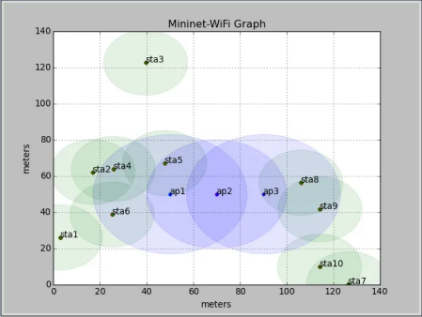

The Mininet-WiFi extended the base Mininet code by adding or modifying classes and scripts. So, Mininet-WiFi adds new functionality and **still supports all the normal SDN emulation** capabilities of the standard Mininet network emulator.

https://hackmd.io/@pmanzoni/rkMF11rIH 2/12

4/22/24, 9:55 AM Mininet Lab 3: WiFi networks - HackMD

Please refer to the Mininet-WiFi documentation for up-to-date information about this project. At the top of that page is a link to the Mininet-WiFi manual, which is currently hosted at: https://github.com/ramonfontes/manual-mininet-wifi/raw/master/mininet-wifi draft-manual.pdf (https://github.com/ramonfontes/manual-mininet-wifi/raw/master/mininet-wifi-draft manual.pdf).

**802.11 Wireless LAN Emulation**

Mininet-wifi incorporates the Linux 802.11 SoftMAC

(https://wireless.wiki.kernel.org/en/developers/documentation/glossary#softmac) wireless drivers, the cfg80211 (https://www.kernel.org/doc/html/v4.12/driver-api/80211/cfg80211.html) wireless configuration interface and the mac80211_hwsim (https://wireless.wiki.kernel.org/en/users/drivers/mac80211_hwsim) wireless simulation drivers in its access points.

The **mac80211hwsim** driver is a software simulator for Wi-Fi radios. It can be used to create virtual Wi-Fi interfaces that use the 802.11 SoftMAC wireless LAN driver. Using this tool, it is possible to emulate a Wi-Fi link between virtual machines.

This driver enables to emulate the wifi protocol control messages passing between virtual wireless access points and virtual mobile stations in a network emulation scenario. By default, it simulates perfect conditions, which means **there is no packet loss or corruption**.

You can use Wireshark to monitor wireless traffic passing between the virtual wireless access point and the virtual mobile stations in the Mininet-wifi network scenarios, but, you will find it is difficult to capture wireless control traffic on standard WLAN interfaces like ap1-wlan0 because the **Linux kernel strips wireless control messages and headers before making traffic on these interfaces available to user processes** like Wireshark.

This issue is solved using the so-called **hwsim0 interface**. This interface replays communications sent onto the access point’s simulated wireless interface(s) such as ap1-wlan0 without stripping any 802.11 headers or control traffic3. We’ll see how to do this in the examples below.

**Topics covered in this lab**

This lab session will present the basic functionalities of Mininet-WiFi by working through two steps:

**Step 1**: One access point shows how to run the simplest Mininet-WiFi scenario, shows how to capture wireless traffic in a Mininet-Wifi network.

**Step 2**: Multiple access points shows how to create a more complex network topology so we can experiment with a very basic mobility scenario.

https://hackmd.io/@pmanzoni/rkMF11rIH 3/12

4/22/24, 9:55 AM Mininet Lab 3: WiFi networks - HackMD

**Step 1: One access point**

The simplest network is the default topology, which consists of a wireless access point with two wireless stations. The access point is a switch connected to a controller. The stations are hosts.

This simple lab will allow us to demonstrate how to capture wireless control traffic and will demonstrate the way an OpenFlow-enabled access point handles WiFi traffic on the wlan interface.

**Capturing Wireless control traffic in Mininet-WiFi**

To view wireless control traffic we must first start Wireshark:

$ sudo wireshark

Then, start Mininet-WiFi with the default network scenario using the command below: $ sudo mn --wifi

1.- Usando dump y net determina la estructura de la red creada.

Next, **enable the hwsim0 interface**. The hwsim0 interface is the software interface created by Mininet-WiFi that copies all wireless traffic to all the virtual wireless interfaces in the network scenario. It is the easiest way to monitor the wireless packets in Mininet-WiFi.

mininet-wifi> sh ifconfig hwsim0 up

Now, in Wireshark, refresh the interfaces and then start capturing packets on the hwsim0 interface.

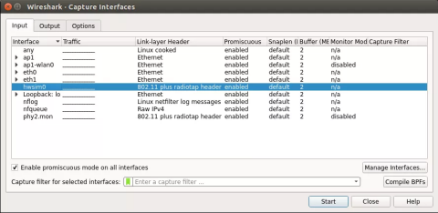https://hackmd.io/@pmanzoni/rkMF11rIH 4/12

4/22/24, 9:55 AM Mininet Lab 3: WiFi networks - HackMD

You should see wireless control traffic. Next, execute a ping command:

mininet-wifi> sta1 ping sta2

In Wireshark, see the wireless frames and the ICMP packets encapsulated in Wireless frames passing through the hwsim0 interface.

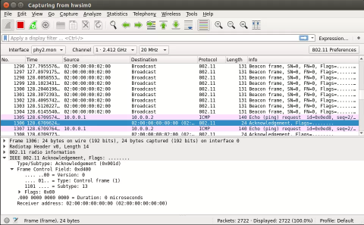Stop the ping command by pressing Ctrl-C. .

**Wireless Access Points and OpenFlow**

In this simple scenario, the access point has only one interface, ap1-wlan0. By default, stations associated with an access point connect in infrastructure mode so wireless traffic between stations must pass through the access point. If the access point works similarly to a switch in standard Mininet, we expect to see OpenFlow messages exchanged between the access point and the controller whenever the access point sees traffic for which it does not already have flows established.

To view OpenFlow packets, stop the Wireshark capture and **switch to the loopback interface**. Start capturing again on the loopback interface. Use the *openFlow_v1* filter to view only OpenFlow messages.

Then, start some traffic running with the ping command and look at the OpenFlow messages captured in Wireshark.

mininet-wifi> sta1 ping sta2

You can see some of the messages flowing through.

https://hackmd.io/@pmanzoni/rkMF11rIH 5/12

4/22/24, 9:55 AM Mininet Lab 3: WiFi networks - HackMD

Stop the Mininet ping command by pressing Ctrl-C.

In the Wireshark window, stop capturing and quit Wireshark.

Stop Mininet-Wifi and clean up the system with the following commands:

mininet-wifi> exit

wifi:~$ sudo mn -c

**Mininet-WiFi step #2: Multiple access points**

When we create a network scenario with two or more wireless access points, we can show more of the functions available in Mininet-WiFi.

In this step, we will create a linear topology with three access points, where one station is connected to each access point.

Run Mininet-Wifi and create a linear topology with three access points: $ sudo mn --wifi --topo linear,3

From the output of the command, we can see how the network is set up and which stations are associated with which access points.

*** Creating network

*** Adding controller

*** Adding hosts and stations:

sta1 sta2 sta3

*** Adding switches and access point(s):

ap1 ap2 ap3

*** Adding links and associating station(s):

(ap2, ap1) (ap3, ap2) (sta1, ap1) (sta2, ap2) (sta3, ap3)

*** Starting controller(s)

c0

*** Starting switches and access points

ap1 ap2 ap3 ...

*** Starting CLI:

mininet-wifi>

We can also verify the configuration using the Mininet CLI commands net and dump

mininet-wifi> net

sta1 sta1-wlan0:None

sta2 sta2-wlan0:None

sta3 sta3-wlan0:None

ap1 lo: ap1-eth1:ap2-eth1

ap2 lo: ap2-eth1:ap1-eth1 ap2-eth2:ap3-eth1

ap3 lo: ap3-eth1:ap2-eth2

c0

https://hackmd.io/@pmanzoni/rkMF11rIH 6/12

4/22/24, 9:55 AM Mininet Lab 3: WiFi networks - HackMD

From the net command above, we see that ap1, ap2, and ap3 are connected together in a linear fashion by Ethernet links. But, we do not see any information about to which access point each station is connect. This is because they are connected over a “radio” interface so we need to run the standard **iw** command at each station to observe to which access point each is associated.

To check which access points are “visible” to each station, use the **iw scan** command:

mininet-wifi> sta1 iw dev sta1-wlan0 scan | grep ssid

SSID: ssid_ap1

SSID: ssid_ap2

SSID: ssid_ap3

Verify the access point to which each station is currently connected with the **iw link** command. For example, to see the access point to which station sta1 is connected, use the following command:

mininet-wifi> sta1 iw dev sta1-wlan0 link

Connected to 02:00:00:00:03:00 (on sta1-wlan0)

SSID: ssid_ap1

freq: 2412

RX: 1853238 bytes (33672 packets)

TX: 7871 bytes (174 packets)

signal: -30 dBm

tx bitrate: 54.0 MBit/s

bss flags: short-slot-time

dtim period: 2

beacon int: 100

mininet-wifi>

**A simple mobility scenario**

In this example, each station is connected to a different wireless access point. We can use the iw command to change which access point to which each station is connected.

Let’s decide we want sta1, which is currently associated with ap1, to change its association to ap2. Manually switch the sta1 association from ap1 (which is ssid_ap1) to ap2 (which is ssid_ap2) using the following commands:

mininet-wifi> sta1 iw dev sta1-wlan0 disconnect

mininet-wifi> sta1 iw dev sta1-wlan0 connect ssid_ap2

2.- verifica el cambio con el comando **iw link** ¿Que obtienes?

So we’ve demonstrated a basic way to make stations mobile, where they switch their association from one access point to another.

https://hackmd.io/@pmanzoni/rkMF11rIH 7/12

4/22/24, 9:55 AM Mininet Lab 3: WiFi networks - HackMD

**OpenFlow flows in a mobility scenario**

Now let’s see how the Mininet reference controller handles this simple mobility scenario.

We need to get some traffic running from sta1 to sta3 in a way that allows us to access the Mininet-WiFi command line. We’ll run the ping command in an xterm window on sta3.

First, check the IP addresses on sta1 and sta3 so we know which parameters to use in our test. The easiest way to see all IP addresses is to run the **dump** command:

mininet-wifi> dump

<Host sta1: sta1-wlan0:10.0.0.1 pid=7091>

<Host sta2: sta2-wlan0:10.0.0.2 pid=7094>

<Host sta3: sta3-wlan0:10.0.0.3 pid=7097>

<OVSSwitch ap1: lo:127.0.0.1,ap1-eth1:None pid=7106>

<OVSSwitch ap2: lo:127.0.0.1,ap2-eth1:None,ap2-eth2:None pid=7110>

<OVSSwitch ap3: lo:127.0.0.1,ap3-eth1:None pid=7114>

<Controller c0: 127.0.0.1:6633 pid=7080>

mininet-wifi>

So we see that sta1 has IP address 10.0.0.1 and sta3 has IP address 10.0.0.3. Next, start an xterm window on sta3:

mininet-wifi> xterm sta3

In that window, run the following command to send ICMP messages from sta3 to sta1: # ping 10.0.0.1

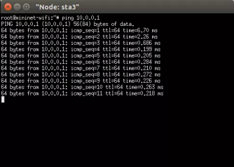

Since these packets will be forwarded by the associated access points out a port other then the port on which the packets were received, the access points will operate like normal OpenFlow-enabled switches. Each access point will forward the first ping packet it receives in

https://hackmd.io/@pmanzoni/rkMF11rIH 8/12

4/22/24, 9:55 AM Mininet Lab 3: WiFi networks - HackMD

each direction to the Mininet reference controller. The controller will set up flows on the access points to establish a connection between the stations sta1 and sta3.

If we run Wireshark and enable packet capture on the Loopback interface, then filter using openflow_v1 we will see OpenFlow messages passing to and from the controller.

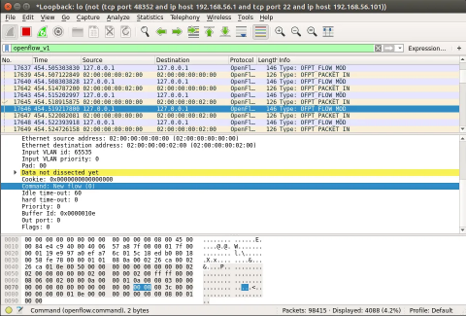Now, in the Mininet CLI, check the flows on each switch with the dpctl dump-flows command.

mininet-wifi> dpctl dump-flows

*** ap1 -----------------------------------------------

NXST_FLOW reply (xid=0x4):

*** ap2 -----------------------------------------------

NXST_FLOW reply (xid=0x4):

idle_timeout=60, idle_age=0, priority=65535,arp,in_port=2,vlan_tci=0x0000,dl_src=02:00: cookie=0x0, duration=1068.17s, table=0, n_packets=35, n_bytes=1470, idle_timeout=60, i cookie=0x0, duration=1073.174s, table=0, n_packets=1073, n_bytes=105154, idle_timeout= cookie=0x0, duration=1073.175s, table=0, n_packets=1073, n_bytes=105154, idle_timeout= *** ap3 -----------------------------------------------

NXST_FLOW reply (xid=0x4):

cookie=0x0, duration=1068.176s, table=0, n_packets=35, n_bytes=1470, idle_timeout=60, idle_timeout=60, idle_age=0, priority=65535,arp,in_port=1,vlan_tci=0x0000,dl_src=02:00: cookie=0x0, duration=1073.182s, table=0, n_packets=1073, n_bytes=105154, idle_timeout= cookie=0x0, duration=1073.185s, table=0, n_packets=1073, n_bytes=105154, idle_timeout= mininet-wifi>

We see flows set up on ap2 and ap3, but not on ap1. This is because sta1 is connected to ap2 and sta3 is connected to ap3 so all traffic is passing through only ap2 and ap3.

What will happen if sta1 moves back to ap1?

https://hackmd.io/@pmanzoni/rkMF11rIH 9/12

4/22/24, 9:55 AM Mininet Lab 3: WiFi networks - HackMD

3.- Muove sta1 otra vez al punto de acceso ap1. ¿Que secuencia de comandos tienes que utilizar?

The ping command running on sta3 stops working. We see no more pings completed.

In this case, access points ap2 and ap3 already have flows for ICMP messages coming from sta3 so they just keep sending packets towards the ap2-wlan0 interface to reach where they think sta1 is connected. **Since ping messages never get to sta1 in its new location, the access point ap1 never sees any ICMP traffic so does not request any flow updates from the controller.**

Check the flow tables in the access points again:

mininet-wifi> dpctl dump-flows

*** ap1 -----------------------------------------------

NXST_FLOW reply (xid=0x4):

cookie=0x0, duration=40.959s, table=0, n_packets=1, n_bytes=42, idle_timeout=60, idle_ cookie=0x0, duration=40.958s, table=0, n_packets=1, n_bytes=42, idle_timeout=60, idle_ *** ap2 -----------------------------------------------

NXST_FLOW reply (xid=0x4):

cookie=0x0, duration=40.968s, table=0, n_packets=1, n_bytes=42, idle_timeout=60, idle_ cookie=0x0, duration=40.964s, table=0, n_packets=1, n_bytes=42, idle_timeout=60, idle_ cookie=0x0, duration=1214.279s, table=0, n_packets=1214, n_bytes=118972, idle_timeout= *** ap3 -----------------------------------------------

NXST_FLOW reply (xid=0x4):

cookie=0x0, duration=40.978s, table=0, n_packets=1, n_bytes=42, idle_timeout=60, idle_ cookie=0x0, duration=40.971s, table=0, n_packets=1, n_bytes=42, idle_timeout=60, idle_ cookie=0x0, duration=1214.288s, table=0, n_packets=1214, n_bytes=118972, idle_timeout= mininet-wifi>

The controller sees some LLC messages from sta1 but does recognize that sta1 has moved to a new access point, so it does nothing. Since the controller does not modify any flows in the access points, none of the ICMP packets still being generated by sta3 will reach sta1 so it cannot reply. This situation will remain as long as the access points ap2 and ap3 continue to see ICMP packets from sta3, which keeps the old flow information alive in their flow tables.

One “brute force” way to resolve this situation is to delete the flows on the switches. In this simple example, it’s easier to just delete all flows.

Delete the flows in the access points using the command below:

mininet-wifi> dpctl del-flows

**Mininet Lab 3: WiFi networks Try**  **HackMD (https://hackmd.io?utm_source=view-page&utm_medium=logo-nav)**

Now the ping command running in the xterm window on sta3 should show that pings are being completed again.

https://hackmd.io/@pmanzoni/rkMF11rIH 10/12

4/22/24, 9:55 AM Mininet Lab 3: WiFi networks - HackMD

Once all flows were deleted, ICMP messages received by the access points do not match any existing flows so the access points communicate with the controller to set up new flows. If we dump the flows we see that the ICMP packets passing between sta3 and sta1 are now traversing across all three acces points.

mininet-wifi> dpctl dump-flows

*** ap1 -----------------------------------------------

NXST_FLOW reply (xid=0x4):

cookie=0x0, duration=10.41s, table=0, n_packets=11, n_bytes=1078, idle_timeout=60, idl cookie=0x0, duration=9.41s, table=0, n_packets=10, n_bytes=980, idle_timeout=60, idle_ *** ap2 -----------------------------------------------

NXST_FLOW reply (xid=0x4):

cookie=0x0, duration=10.414s, table=0, n_packets=11, n_bytes=1078, idle_timeout=60, id cookie=0x0, duration=9.417s, table=0, n_packets=10, n_bytes=980, idle_timeout=60, idle_ *** ap3 -----------------------------------------------

NXST_FLOW reply (xid=0x4):

cookie=0x0, duration=10.421s, table=0, n_packets=11, n_bytes=1078, idle_timeout=60, id cookie=0x0, duration=9.427s, table=0, n_packets=10, n_bytes=980, idle_timeout=60, idle_ mininet-wifi>

We have shown how the Mininet reference controller works in Mininet-WiFi. The Mininet reference controller does not have the ability to detect when a station moves from one access point to another. When this happens, we must delete the existing flows so that new flows can be created. We will need to us a more advanced remote controller, such as OpenDaylight, to enable station mobility but that is a topic outside the scope of this session.

Stop the Mininet ping command by pressing Ctrl-C.

In the Wireshark window, stop capturing and quit Wireshark.

Stop Mininet-Wifi and clean up the system with the following commands:

mininet-wifi> exit

wifi:~$ sudo mn -c

4.- Como ejercio final, ejecuta:

$ sudo ~/RSEmininet/mininet-wifi/examples/miniedit.py

esto hace que aparezca la version adaptada a WiFi del tool Miniedit que has utilizado en la sesion anterior. Define una topologia similar a la del comando

$ sudo mn --wifi --topo linear,3

y genera el codigo .py

https://hackmd.io/@pmanzoni/rkMF11rIH 11/12

4/22/24, 9:55 AM Mininet Lab 3: WiFi networks - HackMD

https://hackmd.io/@pmanzoni/rkMF11rIH 12/12